**Ex.No-1**

# NUMPY

**AIM:**

To calculate the values for the mathematical formulas using NumPy library

# INTEGRATED DEVELOPMENT ENVIRONMENT (IDE) REQUIRED:

JUPYTER NOTEBOOK

# REQUIRED LIBRARIES FOR PYTHON:

* Numpy

# PROCEDURE:

1. **Euclidean distance**

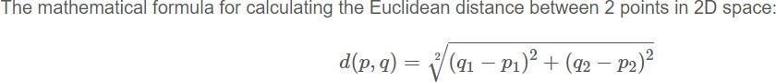

1. **Dot Product**

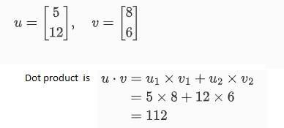

1. **Solving a System of Linear Equations**

A system of linear equations can be represented in matrix form as AX=B, whereA is the matrix of coefficients, X is the column vector of variables, and B is the column vector of solutions. To solve for **X,** we can use: X=A-1 B assuming A is invertible.

# PROGRAM:

1. **Calculating the Euclidean Distance Between Two Points**

importnumpy as np defeuclidean_distance(p, q):

returnnp.sqrt(np.sum((q - p) ** 2)) # Example usage

p = np.array([1, 2])

q = np.array([4, 6])

distance = euclidean_distance(p, q)

print(“Output for Calculating the Euclidean Distance Between Two Points is: “,distance)

1. **Calculating the Dot Product of Two Vectors**

importnumpy as np

A = np.array([1, 3, -5])

B = np.array([4, -2, -1]) dot_product = np.dot(A, B)

print(“Output for dot product of two vectors A and B is “,dot_product)

1. **Solving a System of Linear Equations**

importnumpy as np

# Coefficients matrix A and result vector b A = np.array([[3, 1], [1, 2]])

b = np.array([9, 8]) # Solve for x

x = np.linalg.solve(A, b)

print(“Output solution of System of Linear Equations is “,x)

**Output:**

1. Output for Calculating the Euclidean Distance between Two Points is: 5.0. Exercise 2 –B)Output for dot product of two vectors A and B is 3

C)Output solution of System of Linear Equations is [2. 3.]

**Result:**

The programs were run successfully